Criteria I : Curricular Aspects
Key indicator : 1.4 Feedback System

1.4.1 Structured feedback for design and review of syllabus (semester wise / year wise) is obtained from 1) Students, 2) Teachers, 3) Employers, 4) Alumni
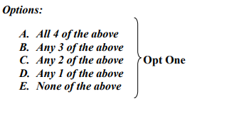
RESPONSE: OPTION A- Sample Feedback forms obtained from all stakeholders

S.NO | STAKEHOLDER | LINK FOR SAMPLE FEEDBACK FORMS
 | Sample Feedback Forms-Students | https://naac.kct.ac.in/1/ssr/1_4_1/Student Filled forms and Analysis.pdf
 | Sample Feedback forms- Teachers | https://naac.kct.ac.in/1/ssr/1_4_1/TEACHER FEEDBACK FORMS.pdf
 | Sample Feedback forms- Employers | https://naac.kct.ac.in/1/ssr/1_4_1/EMPLOYER FEEDBACK FORMS.pdf
 | Sample Feedback forms- Alumni | https://naac.kct.ac.in/1/ssr/1_4_1/ALUMINI FEEDBACK.pdf

